Scenario #63 – Community Solar Credit Allocation Manager
DELIVERABLE 1-EPIC+USER STORIES
EPIC1
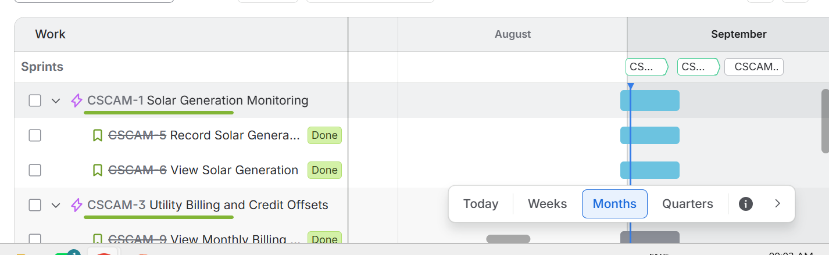
EPIC2
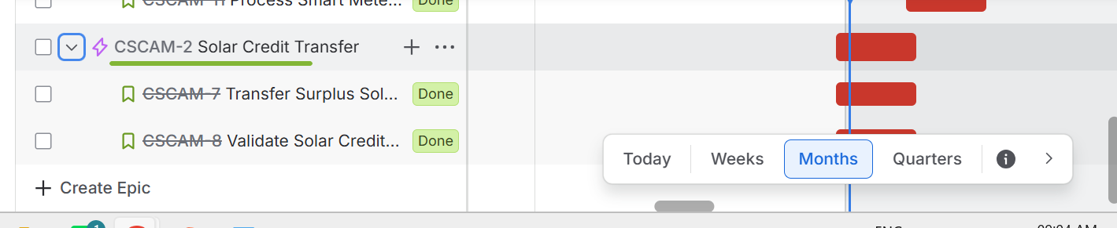
EPIC3

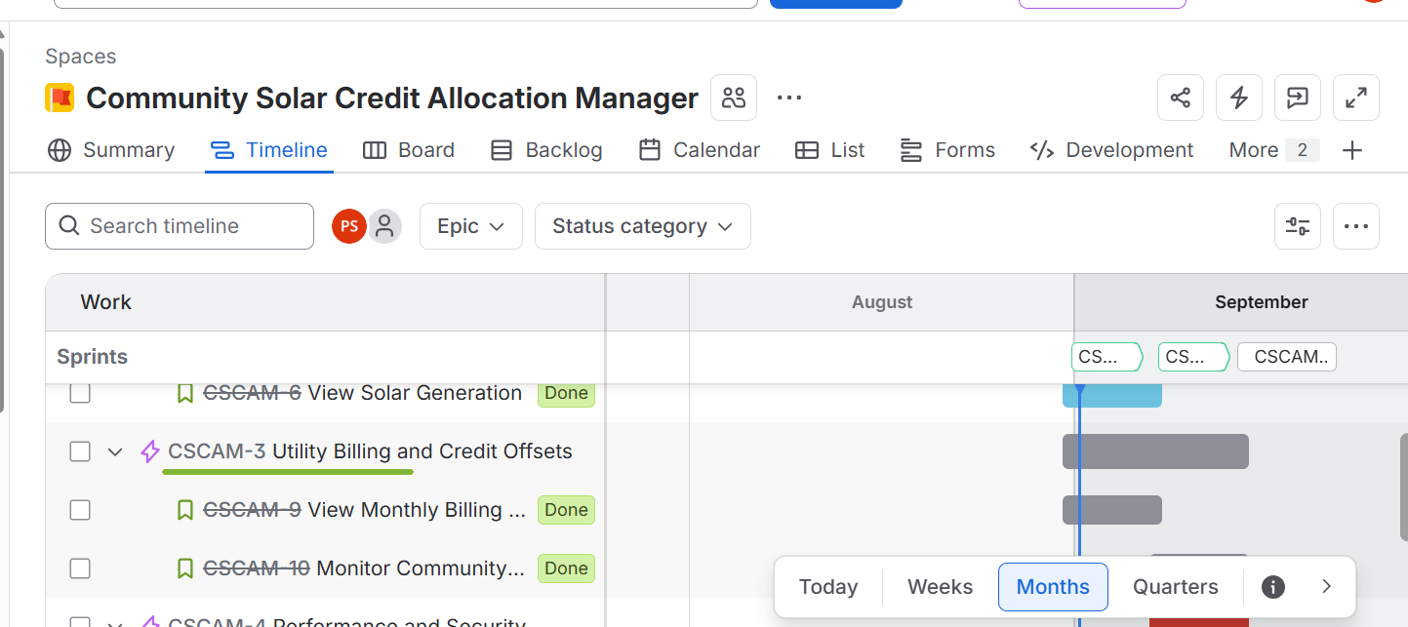
EPIC4
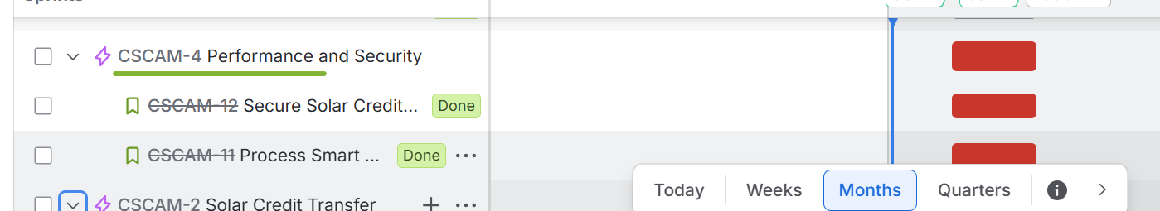

DELIVERABLE 2-COMPLETED SPRINT SCENARIOS
SPRINT 1
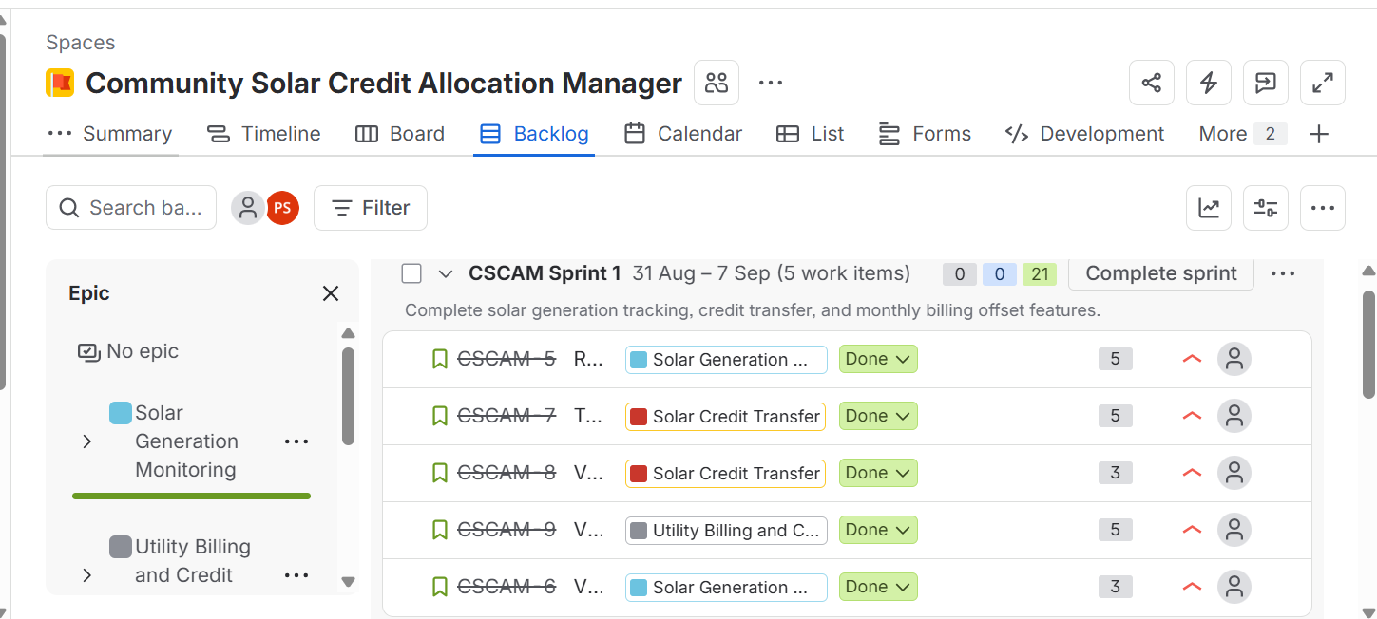

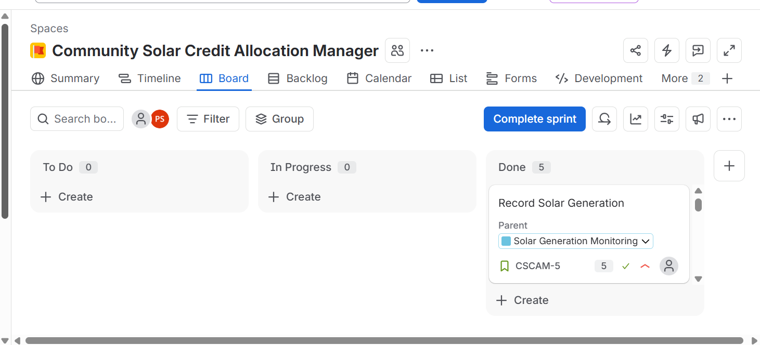

SPRINT 2
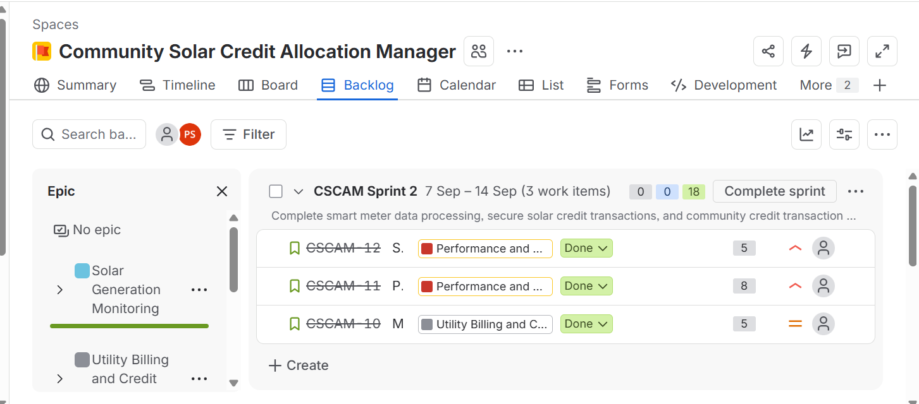
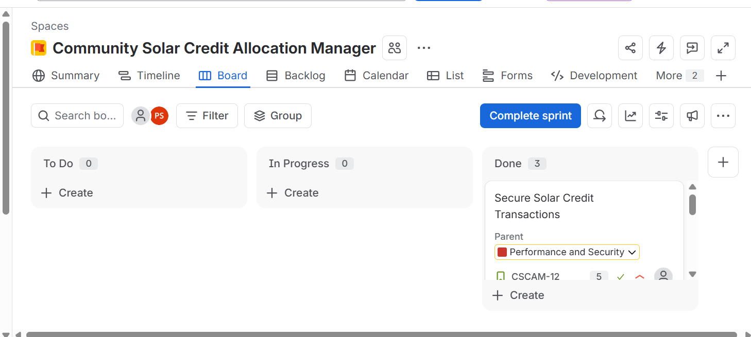

DELIVERABLE 3 -BURNDOUM CHART

SPRINT 1
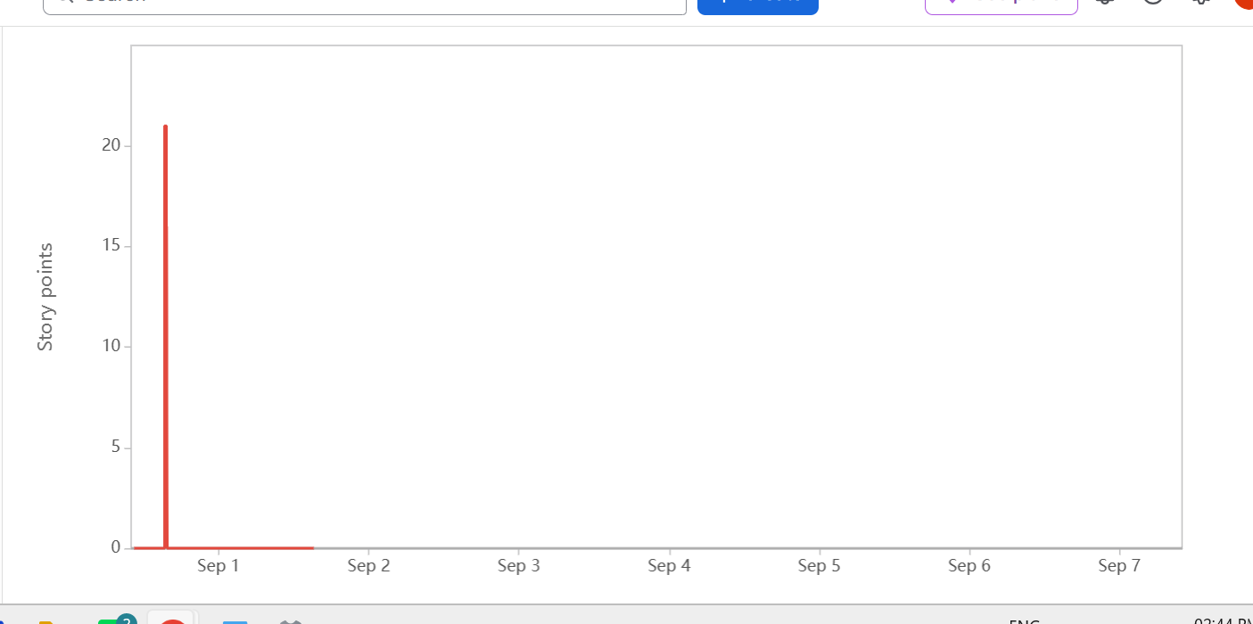
SPRINT2
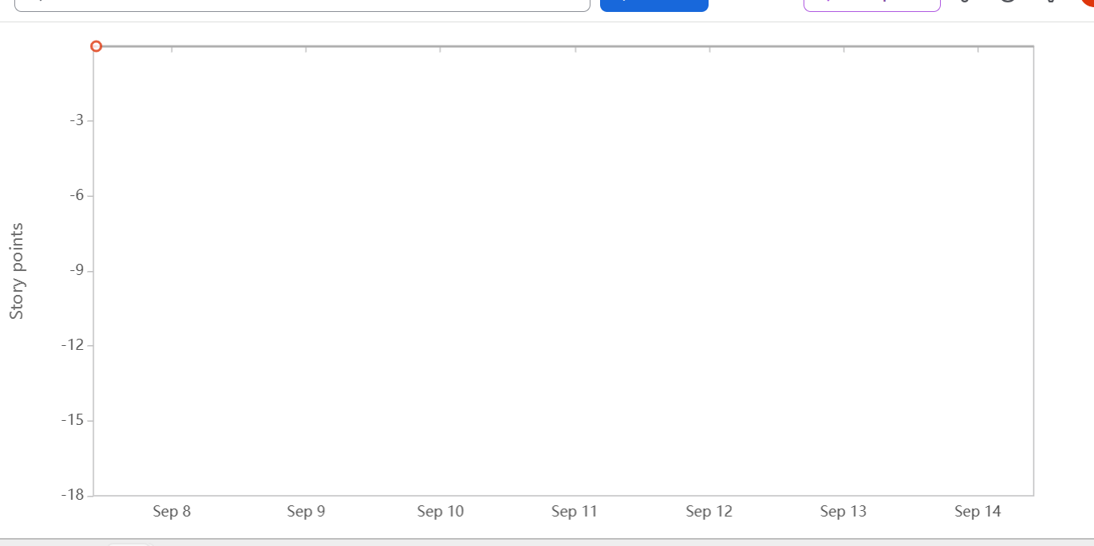

DELIVERABLE 4 -SUMMARY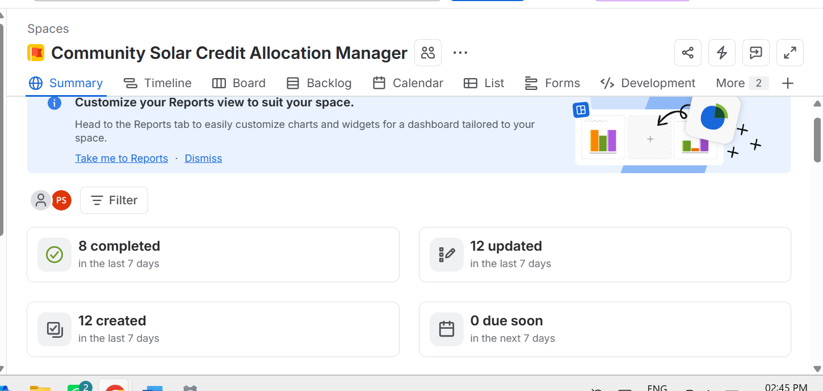
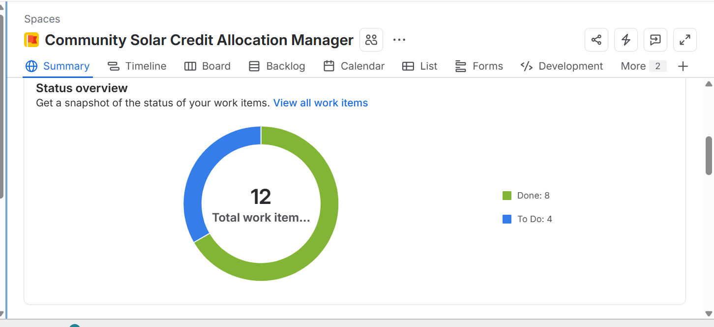
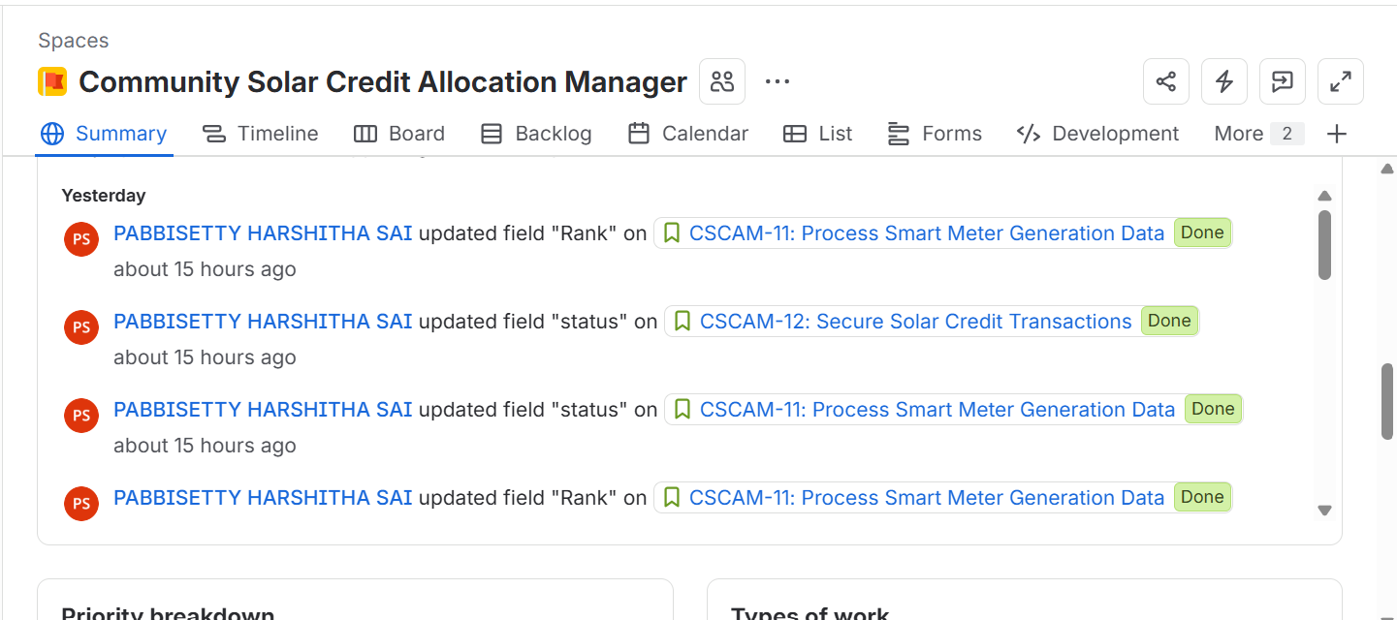

GROUP REFLECTION:
1. What did you learn from the sprint simulation?
I learned how to create and prioritize a backlog, estimate stories using story points, plan a sprint, track work using Jira, and monitor progress using a burndown chart.
2. Was the planned work completed?
Yes. The selected work items were successfully moved through the Jira workflow from To Do to In Progress and finally to Done.
3. What did the burndown chart show?
The burndown chart showed the amount of story-point work remaining during the sprint and helped us track the progress of the sprint.
4. What could be improved?
Future sprints can be improved by estimating work more accurately, breaking large stories into smaller tasks, and monitoring progress regularly.

TABLE:
Epic ID | Epic | User Story ID | User Story
CSCAM-1 | Solar Generation Monitoring | CSCAM-5 | Record Solar Generation
 |  | CSCAM-6 | View Solar Generation
 |  | CSCAM-11 | Process Smart Meter Generation Data
CSCAM-2 | Solar Credit Transfer | CSCAM-7 | Transfer Surplus Solar Credits
 |  | CSCAM-8 | Validate Solar Credit Balance
CSCAM-3 | Utility Billing and Credit Offsets | CSCAM-9 | View Monthly Billing Offset
 |  | CSCAM-10 | Monitor Community Credit Transactions
CSCAM-4 | Performance and Security | CSCAM-12 | Secure Solar Credit Transactions

